**Lab Assignment 3**

**Question 1 :**

F(A, B, C)=ABC + A’BC + AB’C + ABC

**Simplified function,**

F = ABC + A’BC + AB’C + ABC

F = ABC + A’BC + AB’C (Removing Duplicates)

F = BC(A + A’)+ AB’C (Taking BC Common)

F = BC+ AB’C ( A + A’ = 1 )

F = C(B + AB’) (Taking C Common)

F = C(B + A) (Absorption Law)

M = AC + BC

|  |  |  |  |  |  |
| --- | --- | --- | --- | --- | --- |
| A | B | C | AC | BC | AC + BC |
| 0 | 0 | 0 | 0 | 0 | 0 |
| 0 | 0 | 1 | 0 | 0 | 0 |
| 0 | 1 | 0 | 0 | 0 | 0 |
| 0 | 1 | 1 | 0 | 1 | 1 |
| 1 | 0 | 0 | 0 | 0 | 0 |
| 1 | 0 | 1 | 1 | 0 | 1 |
| 1 | 1 | 0 | 0 | 0 | 0 |
| 1 | 1 | 1 | 1 | 1 | 1 |

**Truth Table:**

**Question 2 :**

F(A, B, C)= ABCD’ + A’BC D+ AB’CD’ + ABC

**Simplified function,**

M = AC’D + BCD

|  |  |  |  |  |
| --- | --- | --- | --- | --- |
| A | B | C | D | OUTPUT |
| 0 | 0 | 0 | 0 | 0 |
| 0 | 0 | 0 | 1 | 0 |
| 0 | 0 | 1 | 0 | 0 |
| 0 | 0 | 1 | 1 | 0 |
| 0 | 1 | 0 | 0 | 0 |
| 0 | 1 | 0 | 1 | 0 |
| 0 | 1 | 1 | 0 | 0 |
| 0 | 1 | 1 | 1 | 1 |
| 1 | 0 | 0 | 0 | 0 |
| 1 | 0 | 0 | 1 | 0 |
| 1 | 0 | 1 | 0 | 1 |
| 1 | 0 | 1 | 1 | 0 |
| 1 | 1 | 0 | 0 | 0 |
| 1 | 1 | 0 | 1 | 0 |
| 1 | 1 | 1 | 0 | 1 |
| 1 | 1 | 1 | 1 | 1 |

**Truth Table:**

**Question 3**

F(A, B, C)= m{1, 3, 5, 7, 9, 11, 13}

**Simplified function,**

M = A’D + C’D + AB’D

|  |  |  |  |  |
| --- | --- | --- | --- | --- |
| A | B | C | D | Output |
| 0 | 0 | 0 | 0 | 0 |
| 0 | 0 | 0 | 1 | 1 |
| 0 | 0 | 1 | 0 | 0 |
| 0 | 0 | 1 | 1 | 0 |
| 0 | 1 | 0 | 0 | 1 |
| 0 | 1 | 0 | 1 | 0 |
| 0 | 1 | 1 | 0 | 1 |
| 0 | 1 | 1 | 1 | 1 |
| 1 | 0 | 0 | 0 | 0 |
| 1 | 0 | 0 | 1 | 1 |
| 1 | 0 | 1 | 0 | 1 |
| 1 | 0 | 1 | 1 | 1 |
| 1 | 1 | 0 | 0 | 0 |
| 1 | 1 | 0 | 1 | 1 |
| 1 | 1 | 1 | 0 | 0 |
| 1 | 1 | 1 | 1 | 0 |

**Truth Table:**

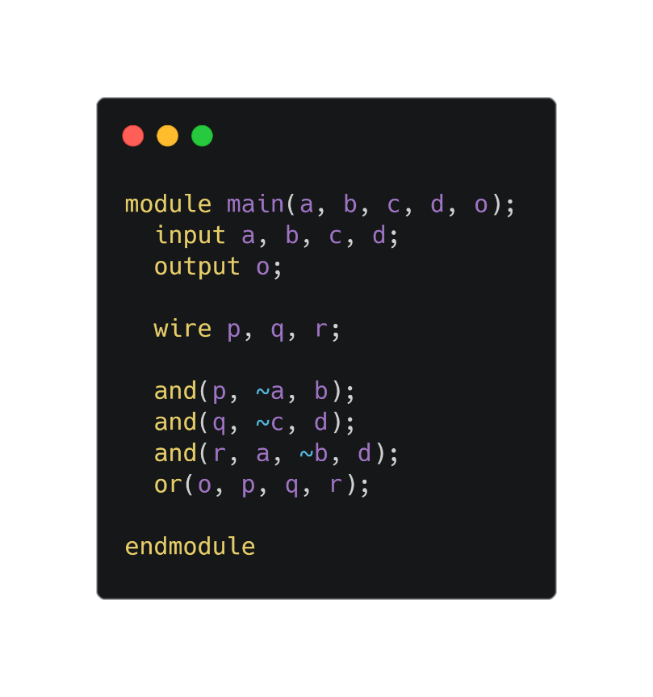**Verilog Code:**

**Quatrus Prime Waveform**

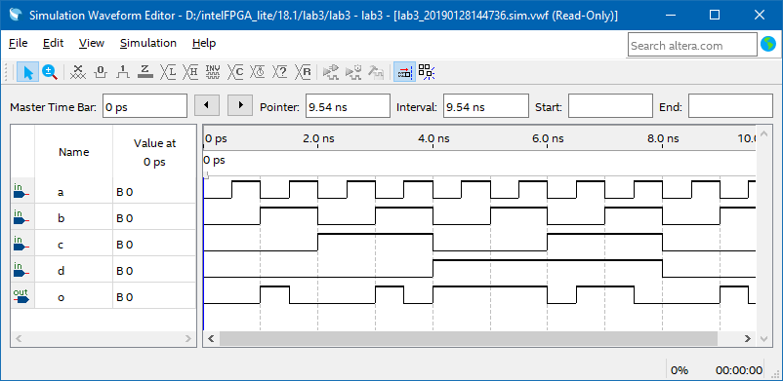

**Question 4**

F(A, B, C)= m {1, 2, 4, 6, 7, 9, 10, 11, 13}

**Simplified function,**

M = B’C’D+AC’D+A’BD’+A’BC+AB’C + B’CD’

|  |  |  |  |  |
| --- | --- | --- | --- | --- |
| A | B | C | D | OUTPUT |
| 0 | 0 | 0 | 0 | 0 |
| 0 | 0 | 0 | 1 | 1 |
| 0 | 0 | 1 | 0 | 1 |
| 0 | 0 | 1 | 1 | 0 |
| 0 | 1 | 0 | 0 | 1 |
| 0 | 1 | 0 | 1 | 0 |
| 0 | 1 | 1 | 0 | 1 |
| 0 | 1 | 1 | 1 | 1 |
| 1 | 0 | 0 | 0 | 0 |
| 1 | 0 | 0 | 1 | 1 |
| 1 | 0 | 1 | 0 | 1 |
| 1 | 0 | 1 | 1 | 1 |
| 1 | 1 | 0 | 0 | 0 |
| 1 | 1 | 0 | 1 | 1 |
| 1 | 1 | 1 | 0 | 0 |
| 1 | 1 | 1 | 1 | 0 |

**Truth Table:**

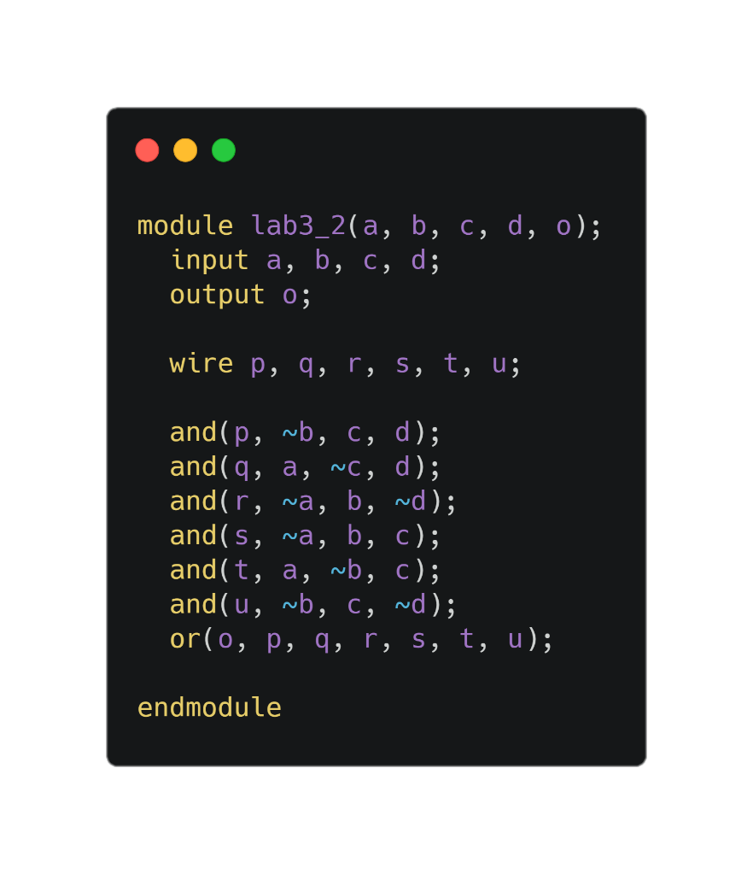**Verilog Code:**

**Quatrus Prime WaveForm:**

